-Name: Solutions Score: ___________ / 40 marks
Instructions: Write answers in the right-hand column.
Section A—Multiple choice (10 marks)

 | For which of the following reactions would the following observation apply:  two colourless solutions are mixed to form a white precipitate.  A a solution of magnesium nitrate is mixed with a solution of sodium sulfate  B solutions of potassium carbonate and nickel chloride are mixed  C dilute hydrochloric acid is added to a solution of silver nitrate AgCl  D a solution of sodium hydroxide is added to dilute nitric acid | C | 2
 | The reaction of sodium sulfite with hydrochloric acid may be represented by the equation:  Na₂SO₃(s) + 2H⁺(aq) → 2Na⁺(aq) + H₂O(l) + SO₂(g).  On the basis of the information in the equation, which one of the following is true?  A When 1 mol of Na₂SO₃ is treated with acid, 1 mole of SO₂ will always be produced.  Not if there is less than 2 mole of the H⁺ ion (i.e. is the LR)  B Na₂SO₃ and H⁺ must always be present in the mole ratio of 1:2 for a reaction to take place.  C The ratio by mass of Na₂SO₃ to H⁺ in a reaction mixture containing the correct stoichiometric proportions is 1:2.  D 0.4 mole of H₂O will be produced when 0.8 mole of H⁺ reacts completely with excess Na₂SO₃. | D | 2
 | When solutions containing calcium ions and phosphate ions are mixed, the following precipitation reaction occurs:  3Ca²⁺(aq) + 2PO₄^{3–}(aq) → Ca₃(PO₄)₂(s)  How many mole of precipitate would form if solutions containing 0.825 mole of Ca²⁺ and 0.520 mole of PO₄^{3–} were mixed? PO₄^{3–} is the LR consuming 0.780 mole of Ca²⁺  A 0.260 mol  B 0.275 mol  C 0.520 mol  D 0.825 mol | A | 2
 | When 0.200 mol of calcium is mixed with 880 g of water, 4.48 L of hydrogen gas form (at STP). How would the volume of hydrogen produced change if the mass of water were to be decreased to 440 g? calcium is LR in both  Ca(s) + 2H₂O(l) → Ca²⁺(aq) + 2OH–(aq) + H₂(g)  A Only one half the volume of hydrogen would be produced.  B The volume of hydrogen produced would be the same.  C The volume of hydrogen produced would double.  D No hydrogen would be produced. | B | 2
 | In an experiment to determine the empirical formula of a chloride of a metal X, a student reduced 0.277 g of the chloride of X to the metal X itself, by using aluminium powder as the reducing agent. She obtained 0.207 g of X. so 0.07 g of Cl  (relative atomic masses: X = 207; Cl = 35)  From these results, the formula of the compound is shown to be:  A XCl  B XCl₂  C XCl₃  D XCl₄ | B | 2

Section B—Written answers (30 marks)

 | a solutions of iron(III) nitrate and potassium hydroxide are mixed  equation:  (2 marks, 1 if not balanced)  An ionic equation is also acceptable  observation:  Pale brown precipitate formed  b solutions of calcium hydroxide and sulfuric acid are mixed to give a precipitate of calcium sulphate, and water.  equation:  (2 marks, 1 if not balanced)  observation:  White precipitate formed. | 6
7 | Liquid hydrazine reacts explosively with hydrogen peroxide according to the equation:  N₂H₄(l) + 2H₂O₂(aq)→ N₂(g) + 4H₂O(g)  Determine the volume, at STP, of gaseous products that would be formed by the reaction of 3.50 L of 4.30 mol L^{–1} hydrogen peroxide with excess hydrazine.  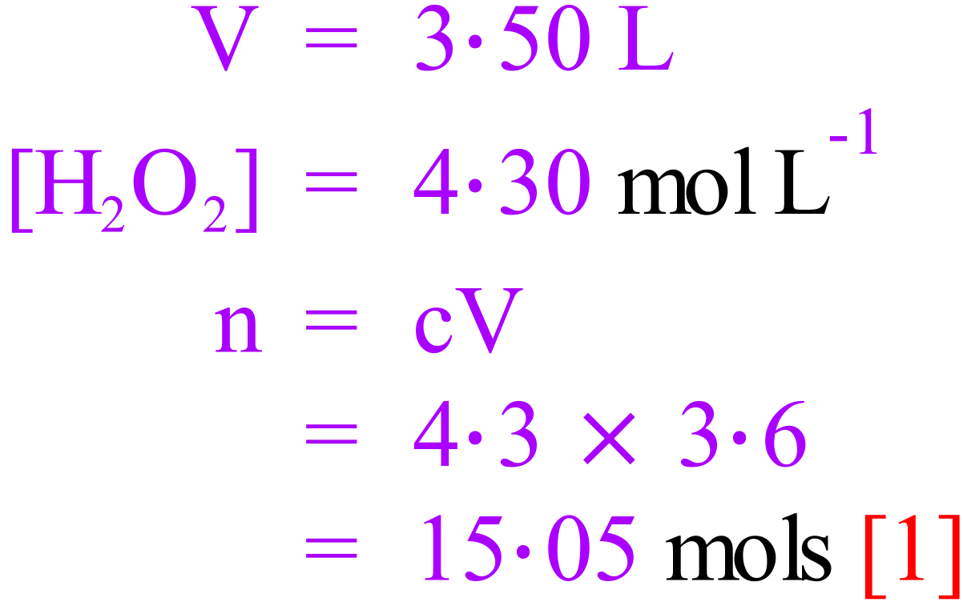  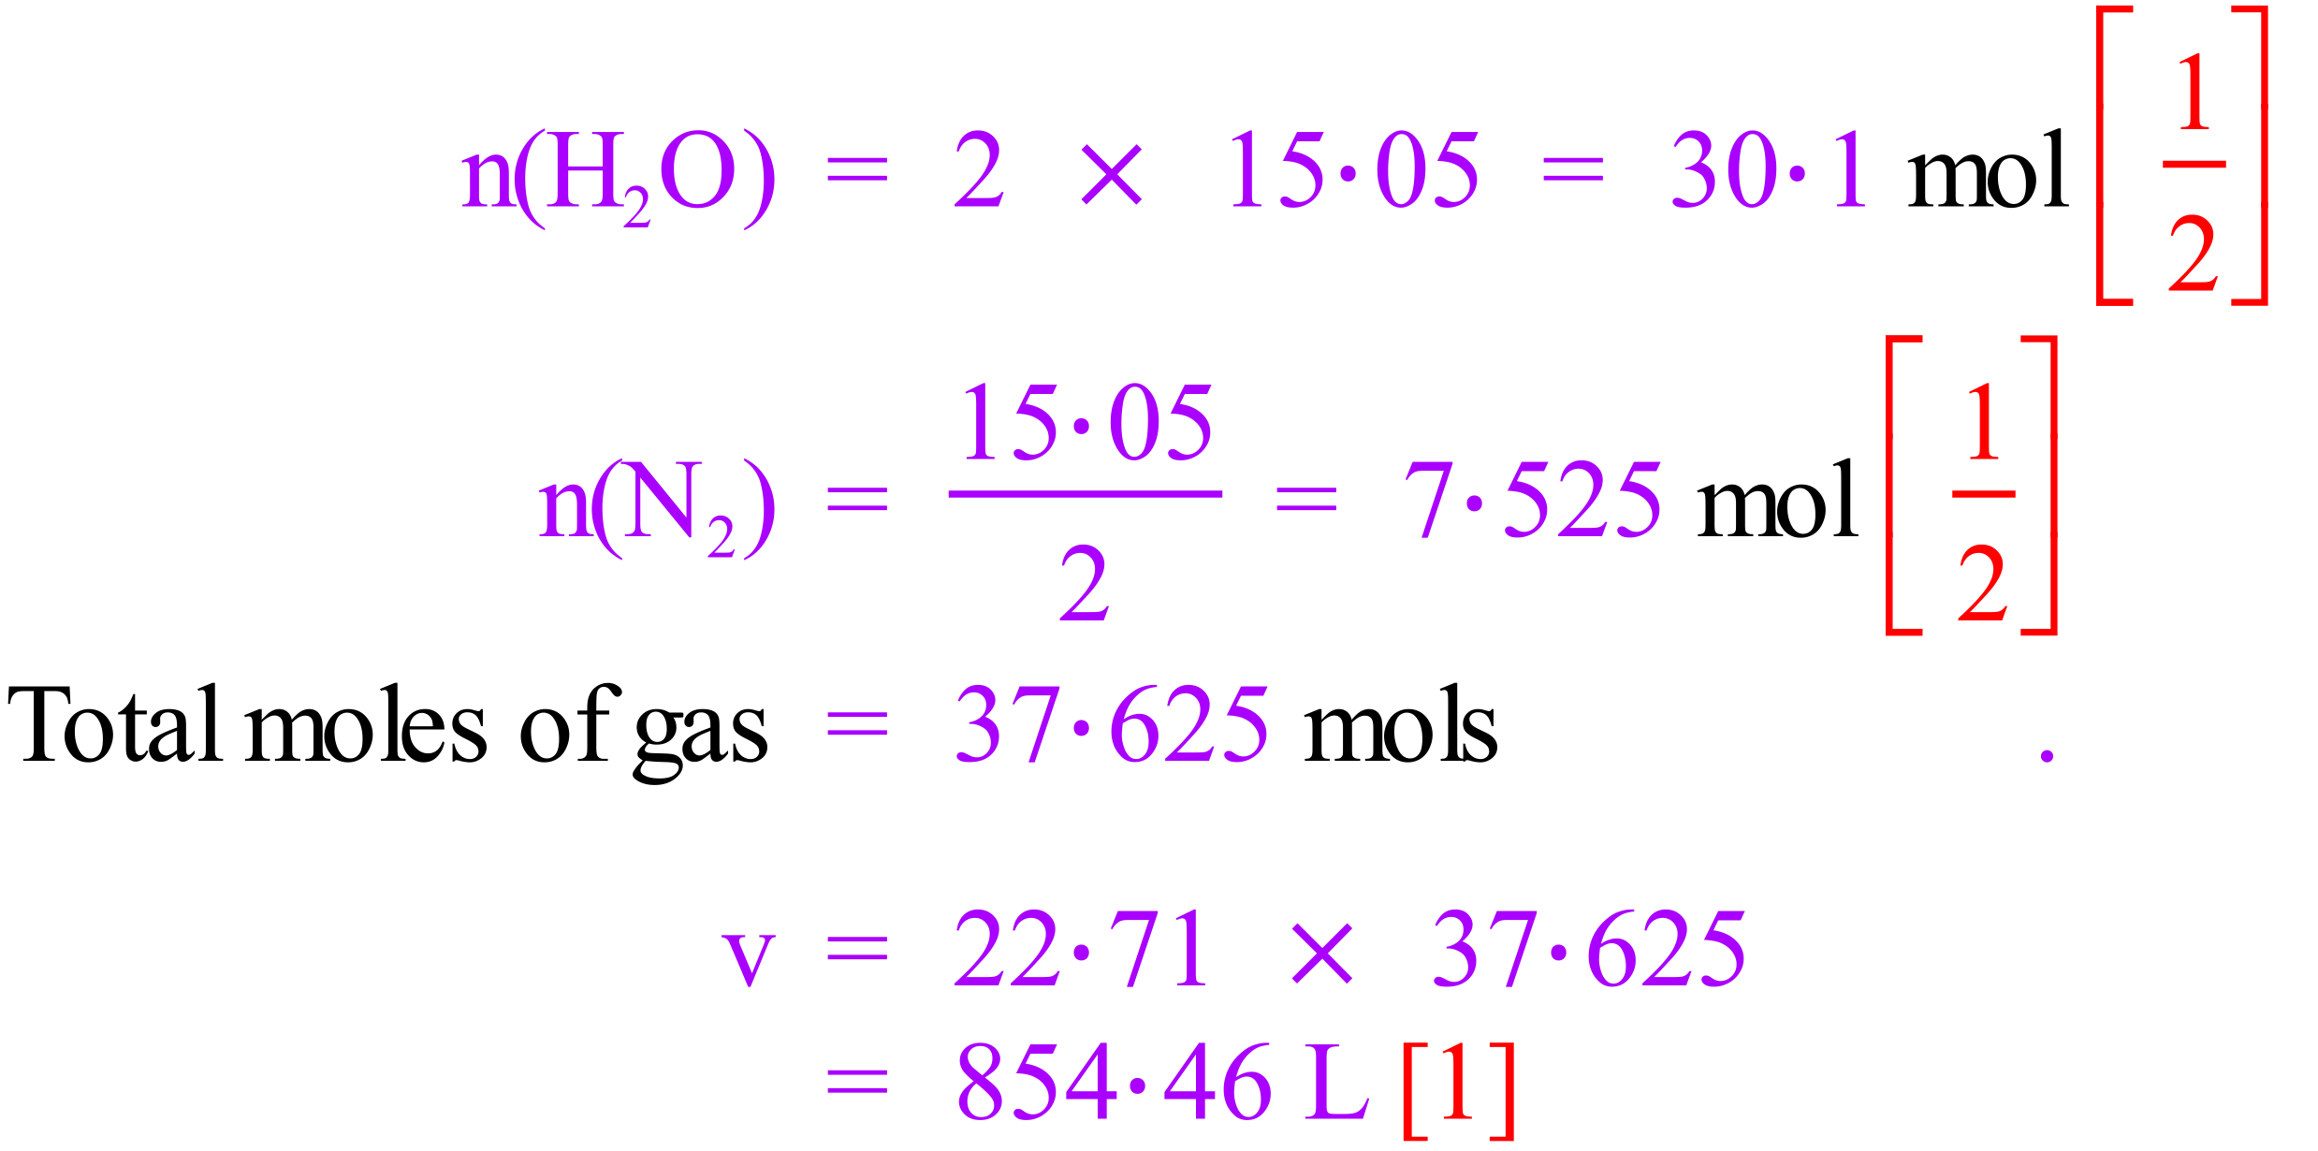  It is also acceptable to state to volume of each gas separately to gain full marks  (H₂O = 683·57 L & N₂ = 170·89 L) | 3
8 | What volume of 0.0712 mol L^{–1} ammonium bromide solution will be required to precipitate all of the mercury(II) ions from 33.6 mL of 0.144 mol L^{–1} mercury(II) nitrate solution? The ionic equation for the reaction is:  Hg²⁺(aq) + 2Br–(aq) → HgBr₂(s)  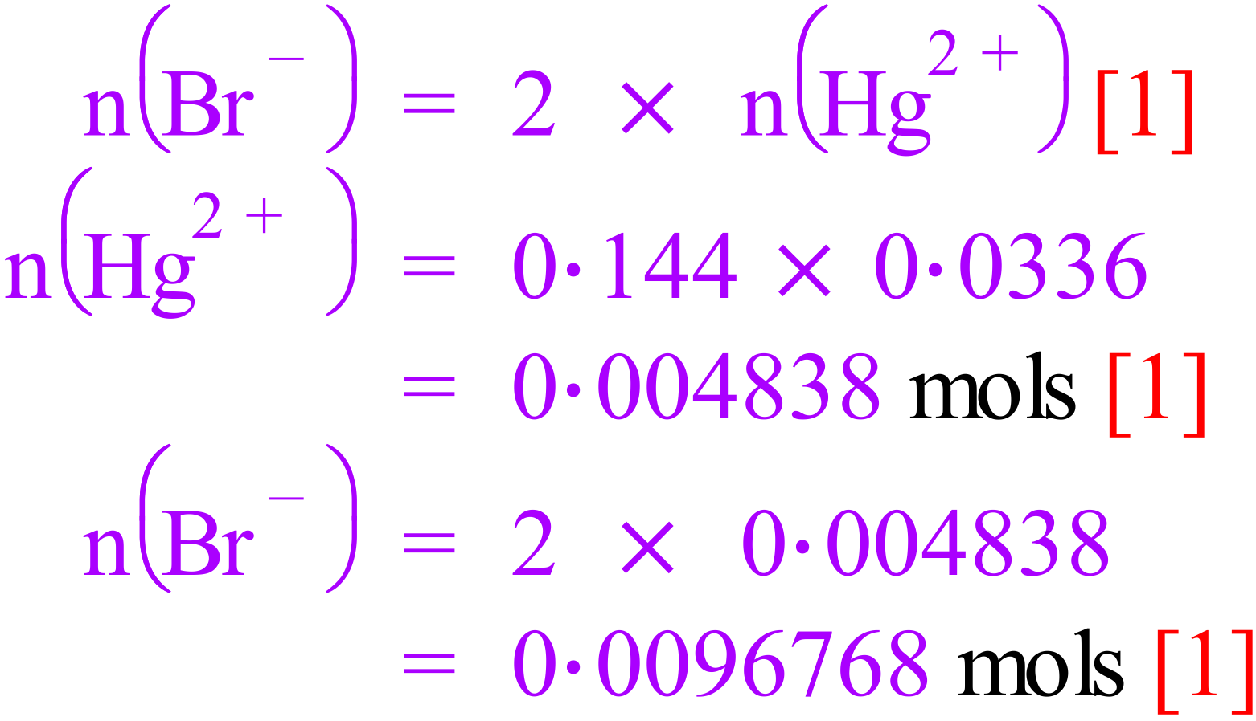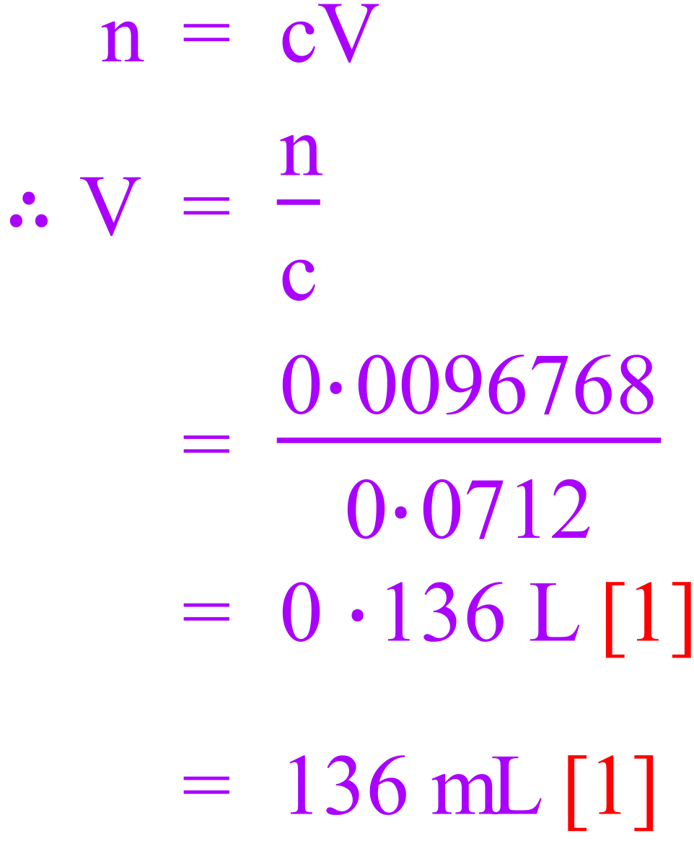 | 5
9 | Ammonium sulfate and calcium hydroxide react in accordance with the following equation:  (NH₄)₂SO₄(s) + Ca(OH)₂(s) → CaSO₄(s) + 2NH₃(g) + 2H₂O(l)  A mixture of 109 g of ammonium sulfate and 53.0 g of calcium hydroxide is gently heated, causing the reaction to occur. What mass of ammonia is produced?  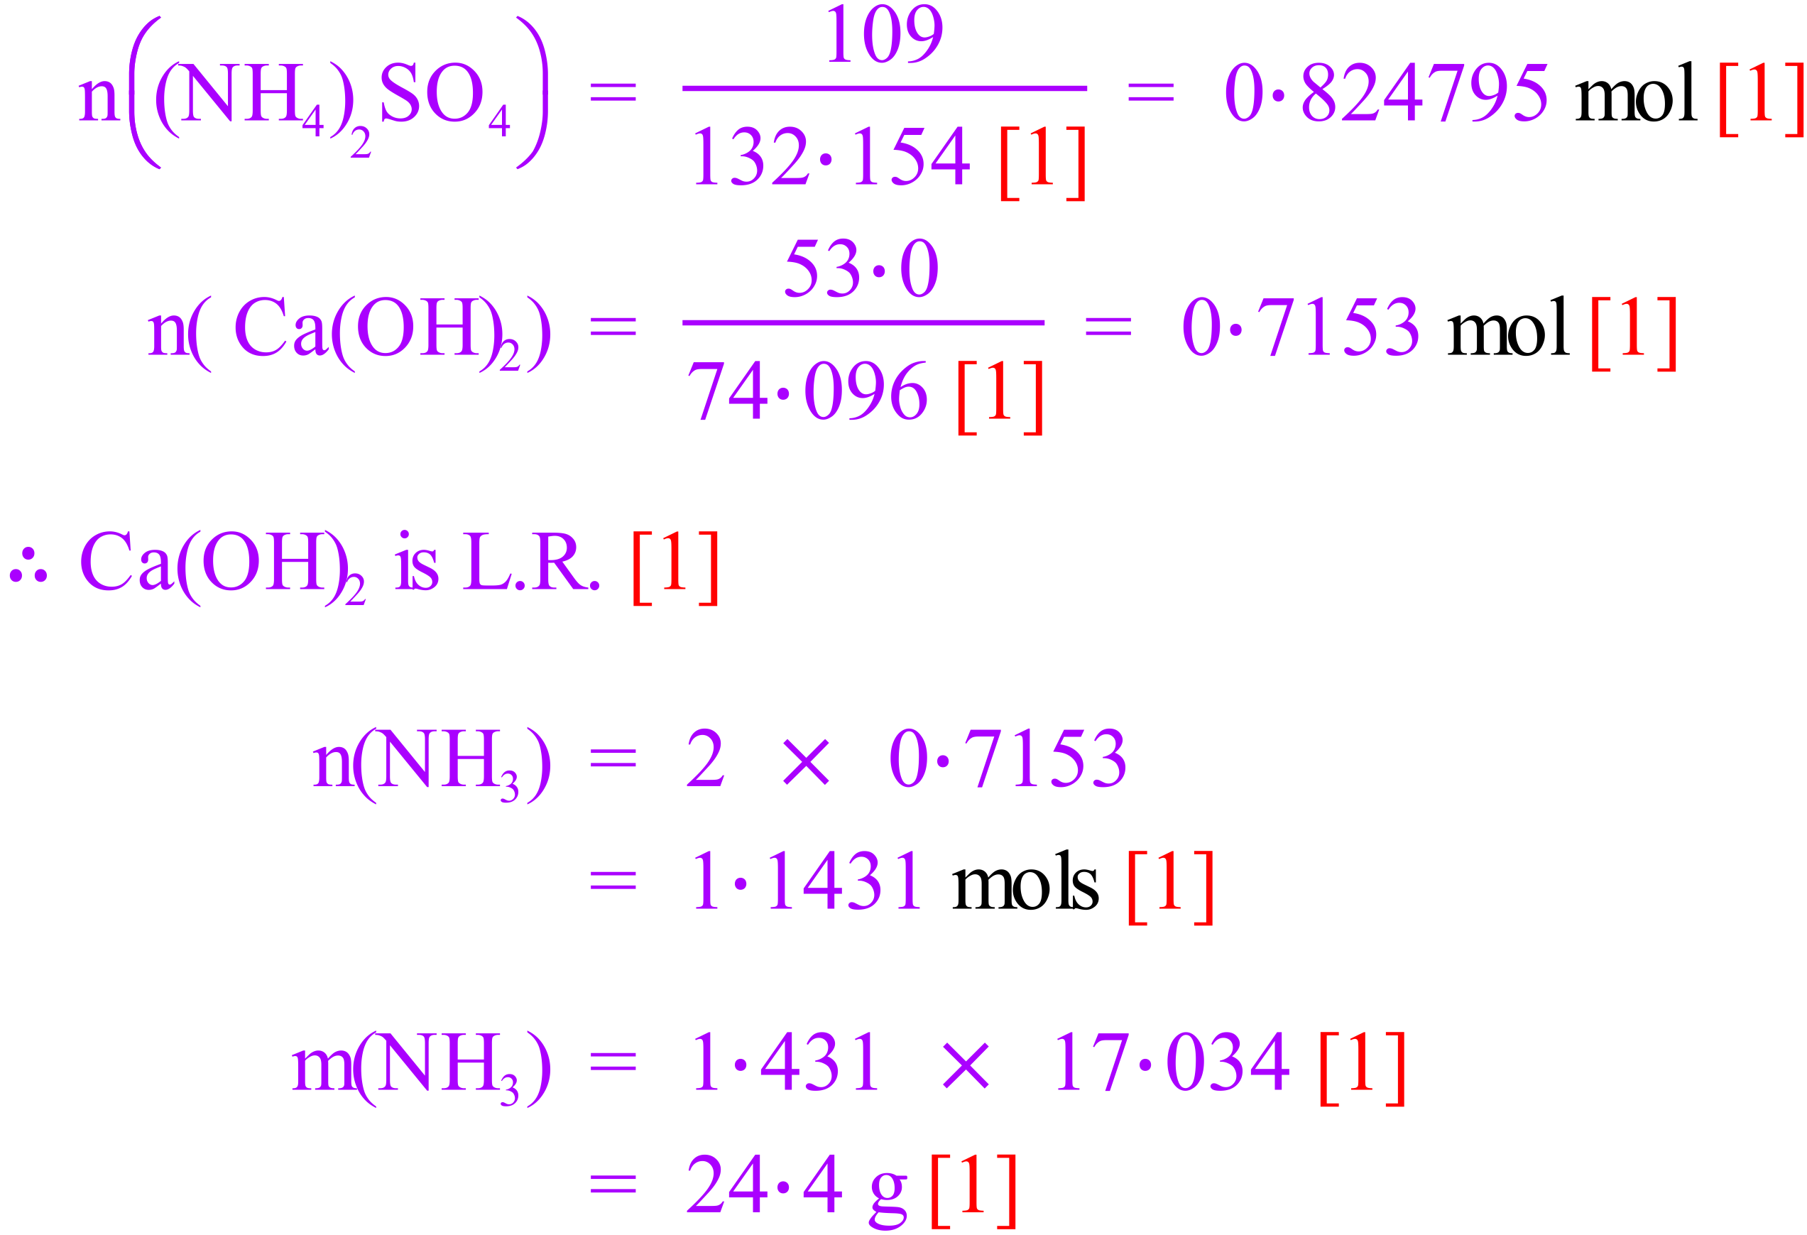 | 8
10 | Sulphuric acid can be manufactured from iron pyrites according to the following sequence of reactions:  4FeS₂ + 11O₂ → 2Fe₂O₃ + 8SO₂  8SO₂ + 4O₂ → 8SO₃  8SO₃ + 8H₂O → 8H₂SO₄  - Calculate the mass of sulphuric acid which could be obtained from 1.00 kg of pure iron pyrite.  - If the iron pyrites is only 85% pure, what mass of sulphuric acid could be produced from 1.00 kg of impure ore?  a)  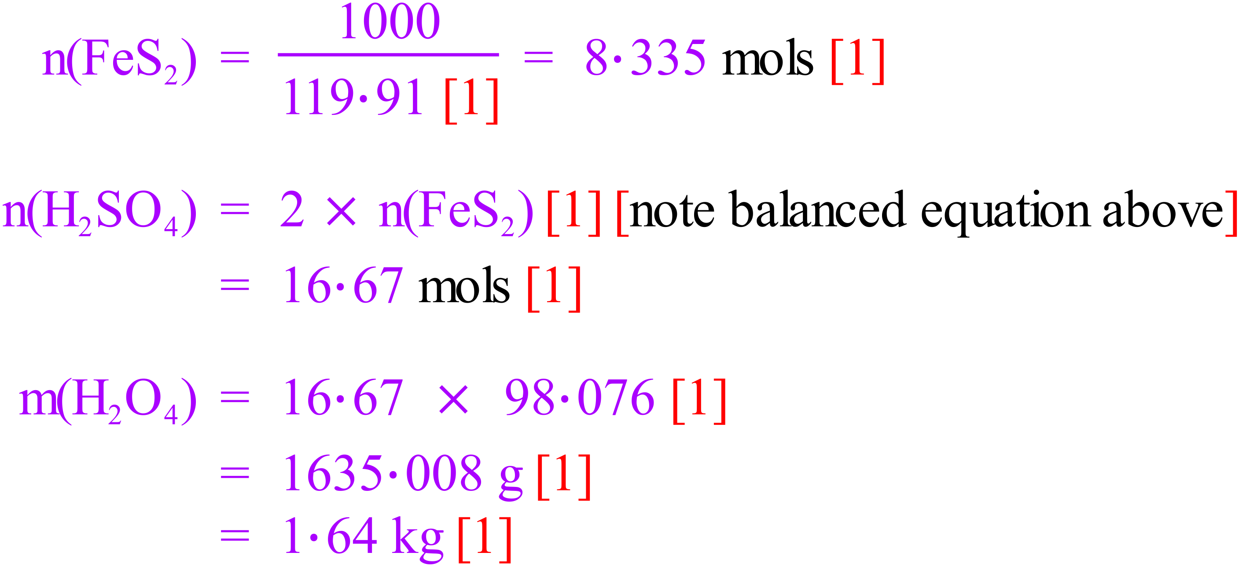  b)  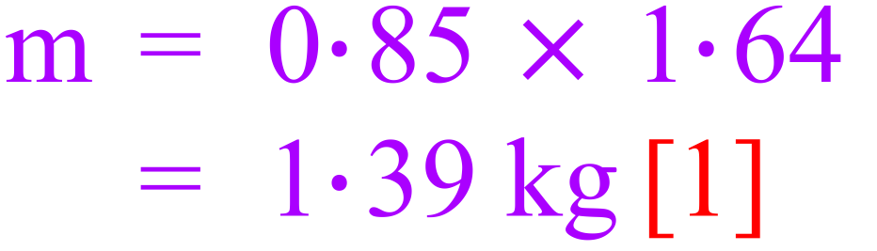 | 8

